# Introduction

The average person spends ninety-thousand hours at work [1]. For office workers, their work environment is vital to their overall health and well-being. This project aims to develop software for a device that improves the well-being of employees and the ergonomics of office spaces. The project will deliver an indoor mapping system using audio technology.

Ergonomics is the study of optimising the work environment to encompass the requirements of the workers there best. The increase of ergonomics in an office space can be correlated to healthier and more productive workers, benefiting all parties. Ergonomics reduces the chances of workplace injury and can help improve employee morale. This, in turn, results in better production and more wealth for the employee. Critical elements of ergonomic office design are the equipment/furniture of the office, the layout and the environmental factors present (such as sound and temperature). [2]

This project into indoor mapping via sound will help companies and their employees, aiding Wellnomics, the University of Canterbury, and most importantly, the group. Wellnomics is a Christchurch based company that is a world leader in ergonomics. Wellnomics develops products to improve the health of employees across the world. Their software is used in a multitude of products that enable businesses to optimise their office environments. Wellnomics will benefit from this project as it has the potential to develop a feature that can be packaged in a device that can be included in hundreds of thousands of desks.

This project also enables engineering students to develop real-world design skills, preparing them for their actual jobs. It forces students to work professionally and understand design thinking. By having regular meetings, presenting findings and setting tasks, students advance their knowledge of engineering procedure and become better engineers.

## User Requirements

The user requirements outline what the project must achieve. These are the initial conditions that must be met for the project to be a success. The project aims to produce software designs and hardware recommendations towards integrating a new 3D mapping feature in the already developed LIMPET. The LIMPET is a Wellnomics design that collects data on various factors around an office. The design for it can be seen below in figure 1.

Figure 1: LIMPET design

The LIMPET is designed to placed on desks and office furniture and continuously collect data throughout the day. It collects temperature, humidity, desk height and other data that impacts the well-being of the user. The aim is to add positioning functionality so that each LIMPETs position can be found in relation to other LIMPETs. The user requirements to achieve this are outlined below in The are summarised below in table 1.

|  |  |
| --- | --- |
| Requirement | Description |
| Measure distance | Various methods can be used to achieve this. The measurements taken are essential to the mapping of the room. |
| Build a model to estimate positions accurately | Using measured distances, a mapping system must be created to accurately position devices. |
| Low cost | The aim is to produce a low cost system, as the LIMPET overall is a low cost solution. |
| Low power requiremen | The LIMPET only has a certain ampunt of available power, and so the hardware used for ythis design cannot draw too much of ths power. |
| Small design | The LIMPET is small device and as such cannot house large hardware. The hardware chosen for this project must be small enough to fit into the LIMPET. |
| Robustness to noise | The Applicable environment may be noise rich and as such the method of communication must be considerate of those. |

Table 1:User Requirements

## Specifications

The specifications outline what the final product will look like and how it fulfils the user requirements. They are summarised below in table 2.

Table 2:Specifications

|  |  |
| --- | --- |
| Specifications | Description |
| Measuring distance using Audio signals. | The devices use a microphone and speaker to communicate noises, which can be turned into distance measurements. |
| Positioning using 3D mesh | Each LIMPET can be treated as an individual node by procuring distance information, and a map of the room can be formed. |
| Sends at specific frequency and wave shape. | To mitigate the impact of noise and attenuation, the transmitted wave can be filtered for and received accurately. |
| MEMs Microphone | A small digital MEMs microphone, SPH0644LM4H-1, is used. These are small, power-efficient and cheap. |
| Mobile Speaker | Similar to the microphone, the speaker used in this design is small and cheap. It is also powerful and can transmit high dB sound. |

## Project Split

The project naturally splits into four sections, The microphone, speaker, sound and the 3D mesh. Each part has equal importance as they are all required for the completion of the project. The sound decides what sort of signal is sent. This signal must be equipped to mitigate attenuation and noise and be reliably transmitted over a distance. The speaker must be driven with the correct input to produce the ideal signal. The proper amplifier must be constructed and tested for this. Similarly, on the other side, the microphone output must be processed and turned into reliable data. Finally, the distance data gained must be turned into 3d mesh.

# Aryan Srivastava Contribution

The contribution involves background research, theoretical designs, simulations, software design and testing to form conclusions. The plan revolves around the concept of audio propagation, an area that the group overall was very inexperienced with. Therefore, a significant amount of time was allocated to research to familiarise the group with audio communications. The research is important, as it enables the formulation of well-thought out conclusions. This report will focus on the wave of the sound and the factors affecting and determining it.

## Background research

The initial background research was to see how sound travelled. This is an integral part of the project, as the sound parameter determines the range and accuracy of the product. To maximise these the background research revolved around what effected the sound, how it was measured and how to maintain clear signal.

The two main factors of sound propagation are the Sound Pressure Level (SPL) and the frequency. The SPL describes the relative ‘loudness’ of the sound [3], while frequency conveys the oscillations in the sound wave.

SPL is one of the methods to measure sound. The others are sound intensity level and sound power level. These parameters portray the sound wave, but SPL was chosen for his project as the microphone and speaker specifications are both given in SPL. SPL describes the ratio of the sound wave pressure and the ambient pressure that the wave is travelling through. The average variation caused by the sound wave in the atmosphere. Their relationship can be described by the equation below,

Where is the pressure of the sound wave, and is the atmospheric pressure. The SPL is used instead of the pure pressure value due to the scale of sound pressure. For example, a sound pressure of 63.2 micro Pascals is equivalent to 10dB, but a 100-dB measurement is 2 Pascals. Due to this wide range of values that produce audible sound, a logarithmic ratio is used to describe sound loudness.

On the surface, the frequency of the wave simply affects the pitch of the sound heard. The audible sound ranges from 20Hz to 20kHz [4]. Beyond those, the human ear cannot pick anything up. But this doesn’t apply to speakers and microphones. Digital and analogue devices can produce and receive sound beyond human hearing range, and they do this due to the other effects’ frequency has on the sound.

Interference is the interaction of two or more waves. Interference can be either in-phase or out of phase, and it can be either destructive or constructive. The figure 2 below illustrates this visually.

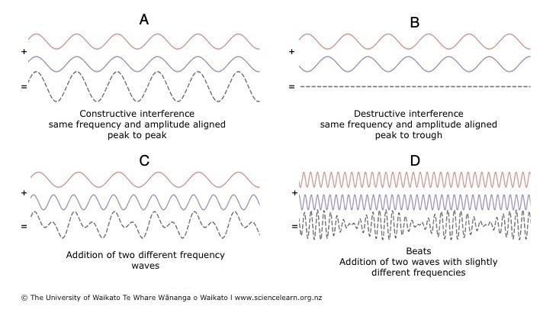

Figure : Visualisation of interference in out of phase and in-phase waves [5]

In the case of A, the signals are in-phase, i.e. they have the same frequency and amplitudes match, and as such, the peaks and troughs of the signal match up and result in constructive interference, as seen but the dotted line output. The signal amplitude here has essentially doubled. Conversely, in B, the signals still have the same frequency, but they do not have matched amplitudes, and as such destructive interference occurs, the amplitudes cancel out. The focus of this project will be more on cases C and D. C and D focus on variations in frequency. When two different frequencies interact, the resultant signal is a ‘noisy’ signal. This signal is distorted in amplitude and, as such harder to detect.

This initial background research defined how sound was measured, how interference can change it, and defined the important parameters that must be investigated further, SPL and frequency.

## Work Undertaken

The work undertaken revolves around further research, making a hypothesis on the frequency required for the project, testing, and then gaining valuable conclusion from it.

### Research

The research focused on factors affecting the SPL of the sound. These included the sound emission at the source, the loss/distortion of sound as it travels, and the noise that may affect the sound.

#### Sound Emission

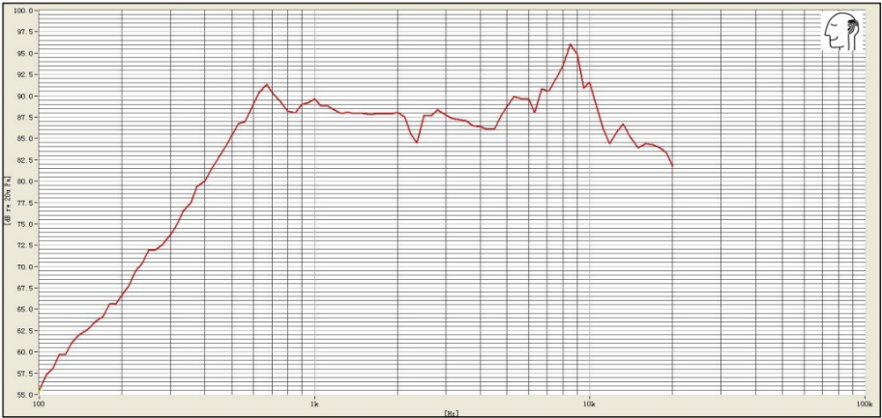The SPL output of the speaker is determined by the frequency. Every speaker has a frequency response, meaning it can propagate specific frequencies better than others. The frequency response for the given speaker can be seen below in figure 3.

Figure : Frequency Response of AS01508MS-SP11-WP-R speaker [23]

The frequency response above 1kHz is 90+ dB for the given speaker, while at lower frequencies, it can even drop to 55dB. This is very important as, on the other side microphones have sensitivity, i.e. they require a certain level of sound to receive the signal accurately. Therefore, the higher SPL is better, and as frequency determines this, the frequency is the most significant decision that must be made in the sound area.

To maximise the SPL transmitted, the effect of the channel must be considered. When sound is emitted, it is subjected to attenuation and noise, both factors that result in loss and distortion. Which ultimately results in lower reliability and range.

#### Attenuation

Attenuation is the loss of sound energy as the wave travels. The absorption of the sound wave can cause this by the air and any objects the wave interacts with.

Attenuation over distance follows the inverse square law. This stipulates that a point source emits a sound wave spherically, which diminishes over distance. This relationship can be described mathematically by the following

Where is the SPL at a distance , and is the SPL at distance [6]. Through this equation, the loss of SPL purely due to distance travelled can be computed. It is frequency independent. The frequency component of attenuation only becomes relevant at high frequencies. At very high frequencies, like 10kHz, the attenuation can potentially be 33dB/km [7].

Finally, there is absorption due to materials. This is measured using the absorption coefficient, which is the percentage of sound absorbed by material on a scale of 0 to 1, 1 being complete absorption. There are two types of materials commonly present in office environments, porous and reflective. Porous absorbers are materials that allow airflow, which lets the sound enter the material and dissipate as heat. These are the materials generally used in sound-proofing, as they prevent the transmission of sound. Some examples are carpet, curtains, plaster and ceiling tiles. These are commonly found materials in offices as most of them are made to reduce noise.

In contrast, reflective materials are generally hard, don’t allow airflow, and minimal sound enters the material. Most of the sound is reflected, and little is absorbed. Typical materials of this type are plywood, glass, and screens. [8].

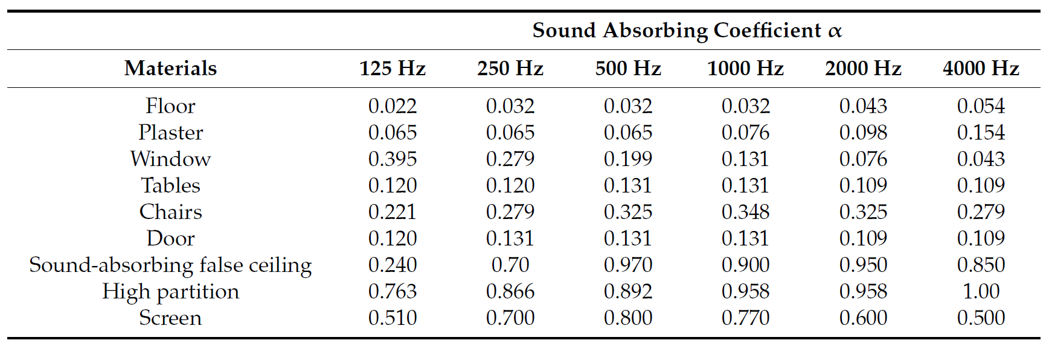Each type of material reacts differently to frequency. Below in figure 4, an example of this can be seen.

Figure : Sound absorption Coefficients of Various Materials. [9]

The reflective materials tend to attenuate lower frequency sound better, while porous materials attenuate higher frequencies better. For example, plaster, a porous material, has an absorption coefficient of 0.154 at 4kHz, while only has a 0.065 coefficient at 125Hz. Conversely, a hard-reflective material like a window has a coefficient of 0.043 at 4 kHz, while at 125 Hz, it has a coefficient of almost 0.4. This illustrates that the chosen frequency will also determine the attenuation loss via objects within the office.

The change in frequency also affects attenuation due to temperature and humidity, due to how air particles are affected. Increases in temperature and humidity result in less attenuation. Still, these factors were not heavily investigated, as the temperature and humidity of the target environment are regulated and not a variable.

In summary, the attenuation of travelling sound is greatly affected by frequency and initial sound pressure. To maximise both, the correct frequency must be chosen.

#### Noise

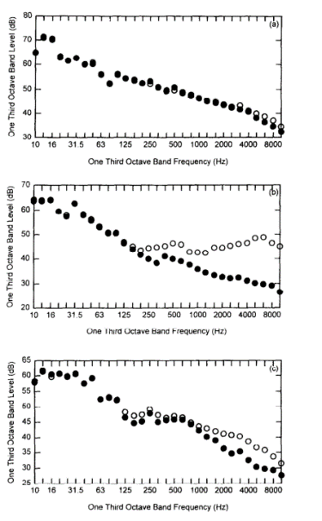Noise is the interference of outside sound sources, corrupting the transmitted signal. The interference of the signal can cause it to lose SPL and be less detectable at the microphone. The main aim of noise investigation is to find common noise sources in an office and what common frequencies are present. This is important so that the chosen frequency is not one that is commonly found in the target environment, and as such, can be easily filtered for without being corrupted. The distribution of noise in an average office can be seen in the figure 5 below.

Figure : Ambient Sound levels in various offices [24]

The figure describes the ambient noise level at different frequencies in 3 various offices. More noise is present at frequencies lower than 1600 Hz, particularly in the sub 250 Hz range. This information is factored into the frequency decision, as ambient noise frequencies with high SPL will interfere with similar frequencies signals and cause loss.

### Theoretical design

Some designs must be thought out once understanding the factors affecting sound and the decisions required to be made for reliable communications. Firstly I examined the environment the device will be applied to. The device will be in an office environment and may potentially only need to be played once or twice a day to gain readings. This is essential as it allows the group to ignore certain factors. For example, due to environmental concerns, temperature and humidity can be narrowed down, as these will be regulated in the office. Also, the ability to choose when to play the sound can mitigate the noise factor, allowing us to select frequencies that may not be available otherwise. Below is a table of design considerations for different frequencies, depending on their limiting factor

Table : Limiting factors of frequency

|  |  |
| --- | --- |
| Limiting factor | Frequency Constraint |
| Speaker | >700 Hz |
| Noise | >1600 Hz |
| Porous Materials | <250 Hz |
| Reflective Material | >1kHz |
| Air Attenuation | <15kHz |

The main concerns now are the attenuation factors due to materials, as they are the most significant constraints. Investigations will be made into which materials are most common in offices and which have the most effect on the transmitted signal. A weighting can be applied to each factor by doing tests and simulations, furthering the end goal of an ideal transmission frequency.

It is also the most significant advantage of the project that the transmitted signal can be standardised. This enables the group to produce a reception filter, which will be tailored for the transmit signal. The signal can be easily band-passed to narrow down the noise.

### Simulations

Simulations were conducted to gain a better understanding of how the sound changed as it travels. The first simulation was to determine the max transmission distance with the current equipment in an undisturbed channel, i.e. no noise or attenuation other than distance. Equation 2 was used to simulate this on MATLAB. The measurement was at 10cm and the was 90dB for the theoretical 1kHz frequency being delivered, found on the frequency response of the speaker. The lowest detectable sound for the microphone can be found by examining its datasheet. The SNR is the difference in decibels between the noise level and the reference signal (1kHz). The microphone does not produce an output if any input signals are below the noise floor, which is defined by the following relationship

By calculating both parameters and graphing them, the intersection will illustrate the max free communication distance. The simulation can be seen below in figure 5

Figure : Attenuation with distance

The calculated noise floor of the microphone was calculated to be 28.5 dB, as indicated by the black line on the figure above. The SPL of the sound falls away as distance increases and interacts with this line at 120m. this is the approximate, max unobstructed communication distance for sound at 1kHz.

Investigating the effect of rising frequency on the air absorption attenuation ISO standard 9613-1 [7] was used to value dB loss over distance. These were plotted in the figure 7 below.

Figure : Affect of Frequency on atmospheric absorption

The attenuation via air increases as the frequency increases, but even at very high frequencies, the loss I relatively small, not even more than 1 dB. This illustrates that the air absorption due to frequency is minimal and that this limitation can be ignored or given less weighting when deciding the output frequency.

Simulations for the attenuation of the conflicting material types, reflective and absorptive were made, to illustrate their differences. The comparison of carpet and plywood can be seen below in figure 8

Figure :

Figure :Comaprision of Absoption Coeffecients for Plywood and Carpet

The opposing trends visualise the difference. One falls as frequency rises while the other rises with it. There is a balance point at 1000 Hz wherein both attenuation coefficients are of comparable values at 0.1. In future simulations, all common materials can be simulated to find common issues where attenuation can be equally minimised.

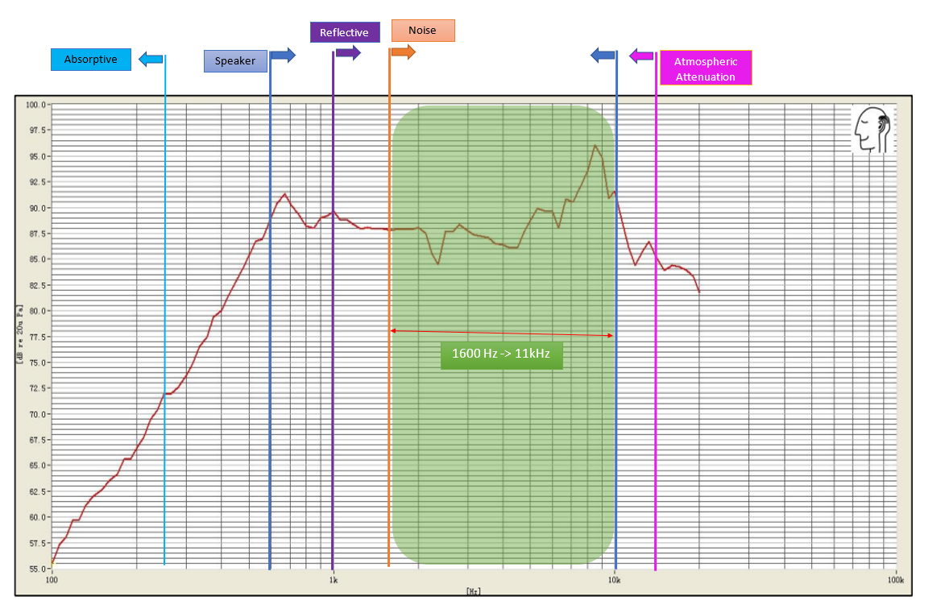Collating all this this theoretical information, a visual diagram was formed to illustrate where the best available frequencies for transmission are. This can be seen in **figure xx.**

Figure : Green Zone Diagram:

The green zone diagram illustrates how the limiting factors affect the choice of frequency. It is overlaid upon the speaker’s frequency response to further illustrate which frequencies within the green zone would be effective. Noticeably there is one bound that cannot be fulfilled. The absorptive (porous) material bound is simply too low for most speakers, and is unlikely to be fulfilled regardless of the apparatus used. To verify the green zone testing was undertaken, using the microphone/speaker system.

### Software design and Test

When testing was due to be done there was no reliable microphone code that could be used to verify the received sound. This meant there was no way to compare the effect of various frequencies on the reception. So, to complete testing some software must be designed for the microphone. The majority of the software design surrounding the microphone will be covered in other sections, this section is specifically software designed for testing purposes.

Initially, there was no way of seeing the output from the mic as a waveform output. Only sound level could be seen, and even then, on a very small, sensitive scale. It used the *rms* function which modelled the microphone output on a scale of 0.0 to 1.0. On this scale the difference between ambient and a received signal was 0.0005, and this was only at a maximum of 8cm away. This was an unacceptable and incorrect result and it was clear the mic needed a better software implementation. To achieve this the *queue* functionality was explored.

The *queue* function solved a key problem in the printing of the mic output. The mic was being sampled at 44kHz, and due to the limitations of the serial monitors of the Arduino IDE software, the sampling rate was too fast for the output. The Arduino IDE’s maximum serial output rate is 115200 bits/sec **(SOURCE).** The output of the mic is stored as a 32-bit floating-point value, and so the effective sample output rate becomes 115200/32, which is far lower than the nominal input and such cannot be output one to one. As such it must be stored in a buffer and output at a slower rate. Luckily there was a *queue* function which enabled exactly this functionality.

The *queue*  function stores 128 samples which can be copied to a buffer periodically, and then printed. Essentially the *queue* begins and data is stored, once the queue is full the data is printed. An overview for this piece of code can be seen in figure xx

The initial filtering is used to remove any noise components in the received data, and this is amplified to reasonable output level. The filter and amplification processes will be described further in later sections. The printed output of the buffer can be seen in **figure xx**

The input for this output was 1kHz signal at a 20 cm range. This clearly verifies the performance of the mic and illustrates that data can be read and seen from it. This will be essential in later stages where the waveform will need to be processed.

### Test section

Testing was completed inside a student work shop room. The room is by no means designed for sound testing, but due to the circumstances it was the best available space. The room had an empty middle space, upon which a desk was place and testing was conducted. This was to reduce the effect of reflection. In another effort to minimize reflection the tests wee taken over a small distance of 1m. This was to guarantee good reception, as the maximum distance was not the factor being tested. The speaker and microphone were placed at 1m distance on a level plane. The set-up is described by **figure xx**

This provided the system with the best possible conditions for transmission. Frequencies were swept from 1kHz to 15kHz in steps of 1kHz, and the output was examined. Maximum amplitude for each frequency was recorded and graphed in **figure xx**

The results verify the hypothesis as the they follow the speaker’s frequency response. There is a considerable rise at 9kHz – 10 kHz and then drop off at 11kHz, as seen in **figure xx**

The second test was to verify the maximum distance of communication. The set up for this was in a long narrow corridor with the mic and speaker again on an even plane. Tests were conducted using the 10kHz frequency, as this was the best one from the past test.

This resulted in a maximum distance to be at 18m (without filtering). When a high pass filter was added for a 10kHz cut-off this distance increased to 24m. Beyond these points the reception would distort or the magnitude of the signal would fall below the noise. The signal shape and magnitude must be maintained for it to be processed further, via either convolution or peak detection (described in further sections).

## Discussion

In accordance with the requirements the sound transmitted must be robust to noise and be able to accurately produce a distance calculation. For both requirements to be fulfilled, the sound must maintain a high SPL. The most important factor affecting the level of sound is the frequency of it. The frequency defines almost all the loss components involved in the signal transmission. Through testing and research conducted the best way to mitigate the loss of SPL is to pick an ideal frequency range which will be least affected by these factors.

Using said research a hypothesis was created in the form of the green zone diagram in **figure xx.** This diagram stipulated that to avoid unwanted factors like noise, attenuation, and subpar hardware performance the frequency chosen must be with the 1600 Hz to 11 kHz range. This hypothesis was then tested and confirmed. The best frequency range found was between 9 kHz and 10kHz.

This raises some considerations. The sound played, if chosen to be between 9kHz and 10kHz will be resilient to almost all factors except porous materials. The absorption for porous materials scales greatly as the frequency rises. This is unfortunate as modern offices are filled with porous materials. For example, carpets, spongy soundproofing barriers and drapes are all examples of absorptive materials. Due to their abundance in the workplace a frequency like 10kHz may be easily absorbed and unsuccessfully transmitted.

With the current implementation choices, i.e., hardware, audible sound, the problem of porous materials is very hard to mitigate. This is due to the very low frequencies required for low absorption, almost at less than 250 Hz. This causes two problems, firstly there are not any speakers of the size Wellnomics are investigating that can produce such low frequencies, and this low frequency will be easily absorbed via reflective materials present in the work environment. As such the research completed indicates that a frequency must be picked to balance the absorption of the two material types, absorptive and reflective. Even if this frequency is not ideal to the hardware used it can still be more effective than the preferred 10kHz frequency.

As such a lower frequency, like 2kHz may be preferable. Even though this does not provide the absolute best speaker performance , as seen in **figure xx** testing, it is the lowest frequency which the absorption co-efficient is less than 0.3. This frequency still lies with in the green zone, and as such still fulfils. The other constraints. The conclusion from this is that even though the 10kHz is the best performing frequency for the system, this may not be case in actual application due to other factors.

The noise in offices is often low frequency, as seen in **figure xx** and as such needs to be accounted for. But if measurements were taken outside of office hours or not in the presence of employees then the noise factor can be largely ignored, leading to a greater spectrum of options. The 1kHz to 1.6kHz range becomes viable if measurements are taken in the absence of noise. This range is again more suitable for porous materials while still providing the hardware and reflective requirements.

In conclusion it is evident from the research and testing that that there are many important factors which contribute to the sound level, but paramount among them is the attenuation via materials. As these will act as barriers and absorb the sound. So, it is important not only examine the mic performance and noise, but to be weary of how frequency will interact with the two material types. I believe a lower frequency such as 1kHz – 2kHz could potentially be used in the absence of noise, or a higher frequency can be used in the absence of porous materials. **Table xx describes the final frequency ranging choices.**

|  |  |
| --- | --- |
| Scenario | Frequency Range |
| Absence of Porous materials | 9kHz – 10kHz |
| Presence of Porous materials | 2kHz |
| Presence of Porous materials, Absence of Noise | 1kHz |

The investigation into sound reveals that the target environment plays a major role, more so than the hardware and then noise present. Both the hardware and the noise can be mitigated via other methods, like changing to a mic which works better in lower frequencies, or by conducting distance measurements in quiet times. But the environment is out of the control of the manufacturer. To best prepare for any environment the suggestion is to use the “Prescence of Porous Materials” case and choose a frequency of ~2kHz for distance measurement. This may be the most reliable frequency when considering the hardware, noise and most importantly attenuation factors present.

## Conclusions

Through research and simulations, I have concluded that the frequency of the delivered sound is essential and perhaps one of the most critical facets of this project. The need to reliably transmit a signal is paramount, as it is the basis of the project. The frequency of the sent signal will determine attenuation, noise impacts and the initial delivery pressure from the microphone. After considering all of these factors and testing, a frequency can be selected to mitigate these factors best and produce the cleanest and strongest communication between LIMPETs.

Appedix

